

Requirement & Design Specification
Multi-store Sales Management System
Version: 1.0

– Hanoi, August 2022 –

Record of Changes
Version | Date | A*  M, D | In charge | Change Description
V1.0 | 20/5/2026 | A | ChiHTH | Context Diagram
V1.0 | 20/5/2026 | A | ChiHTH | Screen Descriptions
V1.0 | 20/5/2006 | A | ThangLV | Screen Authoziation
*A - Added M - Modified D - Deleted

Contents
Record of Changes 2
I. Overview 4
1. User Requirements 4
1.1 Actors 4
1.2 Use Cases 4
a. Diagram(s) 5
b. Descriptions 5
2. Overall Functionalities 5
2.1 Screens Flow 5
2.2 Screen Descriptions 5
2.3 SCREEN AUTHORIZATION 5
System Roles 5
AUTHORIZATION MATRIX 6
1. USER MANAGEMENT 6
2. PRODUCT MANAGEMENT 6
3. SALES MANAGEMENT 7
4. INVENTORY/WAREHOUSE MANAGEMENT 8
5. PURCHASE/SUPPLIER MANAGEMENT 9
6. CUSTOMER MANAGEMENT 10
7. FINANCE MANAGEMENT 11
8. REPORTS 12
8.1 Sales Reports 12
8.2 Inventory Reports 13
8.3 Customer Reports 14
8.4 Financial Reports 14
8.5 Product Reports 15
9. WEBSITE MANAGEMENT 15
2.4 Non-UI Functions 16
3. System High Level Design 24
3.1 Database Design 24
a. Database Schema 24
b. Table Descriptions 24
3.2 Code Packages 24
II. Requirement Specifications 25
1. <<Feature Name>> 25
1.1 <<UseCaseCode_UC Name>> 25
a. Functionalities 25
b. Business Rules 27
2. Common Functions 27
2.1 UC-2_Login System 27
a. Functional Description 27
b. Business Rules 29
3. Patron Feature 29
3.1 UC-5_Order a Meal 29
a. Functional Description 29
b. Business Rules 31
3.2 UC-6_Register for Payroll Deduction 31
a. Functional Description 31
b. Business Rules 32
III. Design Specifications 32
1. <<Feature Name>> 32
1.1 <<SubFeature Name>> 32
a. <<Screen/Function Name>> 32
UI Design 32
Database Access 32
1.2 System Access 33
a. User Login 33
UI Design 33
Database Access 33
b. Setting List 34
UI Design 34
Database Access 34
c. Setting Details 35
UI Design 35
Database Access 35
IV. Appendix 35
1. Assumptions & Dependencies 35
2. Limitations & Exclusions 36
3. Business Rules 36
4. .. 37

I. Overview

1. User Requirements

1.0 Context Diagram
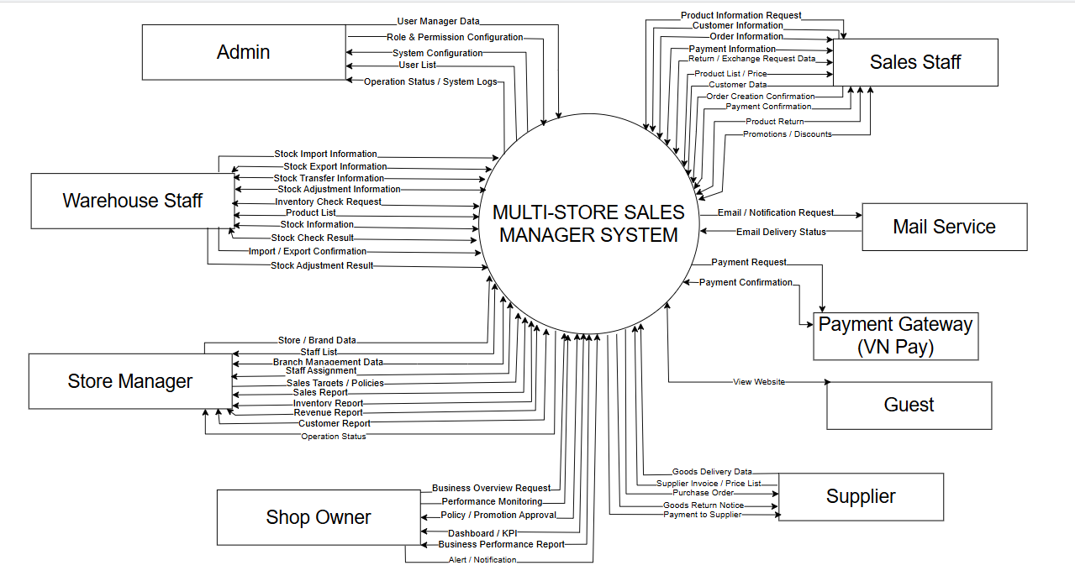

1.1 Actors
# | Actor | Description
1 | Admin | The person with the highest authority in the system is responsible for managing the entire configuration, access control, and technical operation of the system.
2 | Shop Owner | The chain store owner has the right to view all business data and make strategic decisions.
3 | Store Manager | The manager directly oversees a specific point of sale within the chain. They are responsible for the day-to-day operation of that store.
4 | Sales Staff | The staff directly handle sales transactions at the counter.
5 | Warehouse Staff | The employee is responsible for receiving goods, shipping goods, and managing inventory.
6 | Guest | External users can access the company's website. No login is required.

1.2 Use Cases

a. Diagram(s)
[Provide the UC diagram(s) to show the actor-UCs and UC-UC relationships like the sample below. You can have multiple UC diagrams for the system]

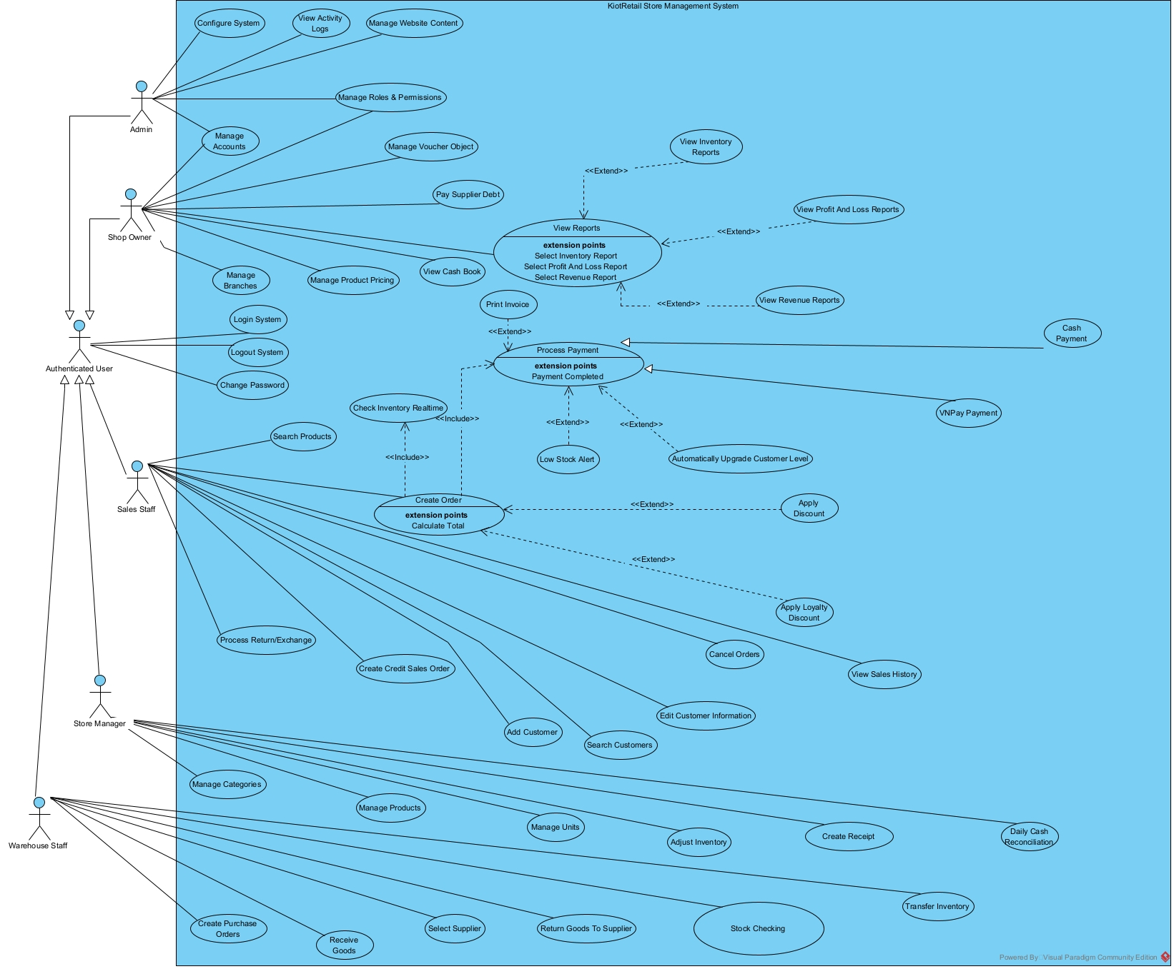
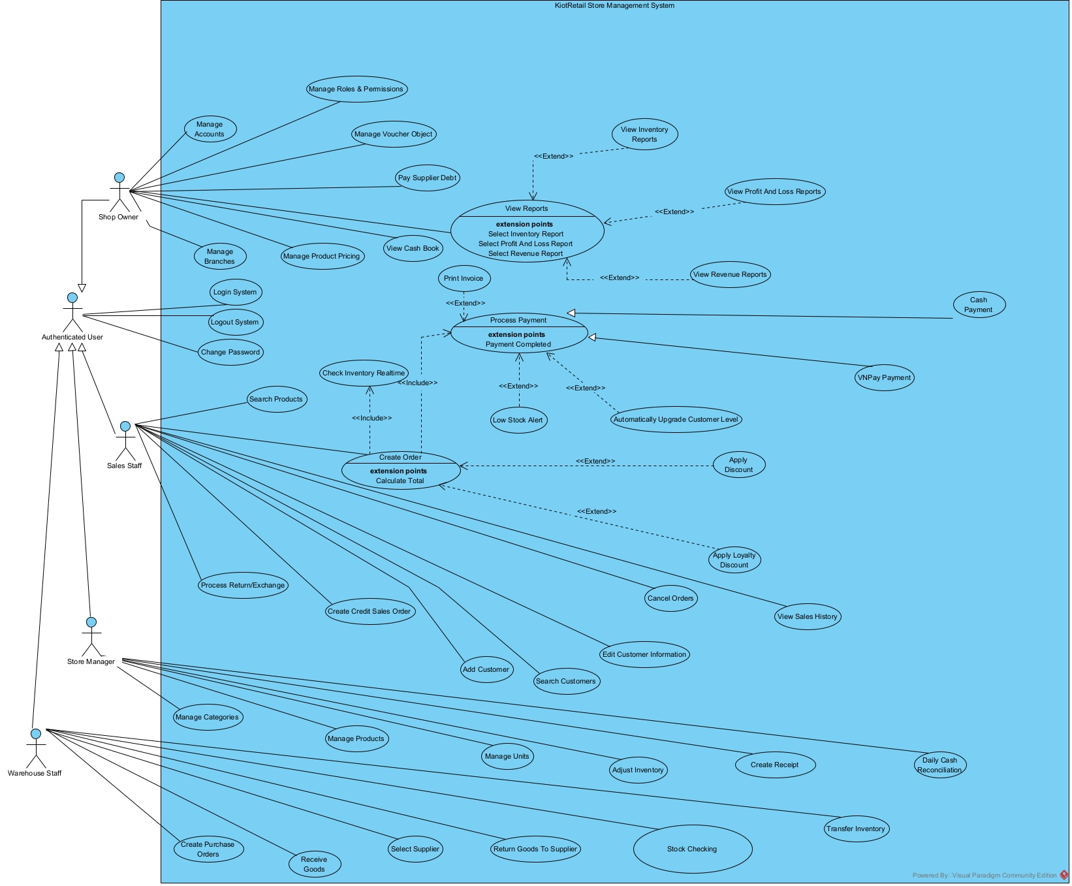

b. Descriptions

ID | Feature | Use Case | Use Case Description
UC-1.1 | Authentication | Login | User logs into the management system using username and password
UC-1.2 | Authentication | Logout | User logs out and ends the working session
UC-1.3 | Authentication | Register | New users create an account by entering required personal information and login credentials. The system validates the input data, checks for duplicate username/email, creates the account, and redirects the user to the login page or dashboard after successful registration.
UC-1.4 | User Management | Manage Staff Accounts | Create, update, lock staff accounts and assign roles
UC-1.5 | Authorization | Manage Roles & Permissions | Create roles and assign permissions to system modules
UC-1.6 | Branch Management | Manage Branches | Add, update or close store branches
UC-1.7 | System Configuration | Configure System | Configure VAT, currency, company information and invoice templates
UC-1.8 | Audit Log | View Activity Logs | Monitor user activity and system logs
UC-2.1 | Audit Log | View System Logs | View system operation history
UC-2.2 | Product Management | Manage Categories | Create, edit and delete product categories
UC-2.3 | Product Management | Manage Products | Manage product information
UC-2.4 | Product Management | Manage Product Pricing | Configure selling prices for each branch
UC-2.5 | Product Management | Search Products | Search products and view stock quantity
UC-3.1 | Product Management | Manage Units | Manage product unit conversions
UC-3.2 | Sales Management | Create Sales Order | Create POS sales orders
UC-3.3 | Sales Management | Apply Discount | Apply discounts to sales orders
UC-3.4 | Payment | Cash Payment | Process cash payments
UC-3.5 | Sales Management | Print Invoice | Print or reprint invoices
UC-3.6 | Sales Management | Process Return/Exchange | Handle product returns and exchanges
UC-3.7 | Sales Management | Cancel Orders | Cancel orders and record cancellation reasons
UC-3.8 | Sales Management | Create Credit Sales Order | Create debt orders for VIP customers
UC-3.9 | Debt Management | Collect Customer Debt | Record customer debt payments
UC-3.10 | Sales Management | View Sales History | View completed sales orders
UC-4.1 | Supplier Management | Manage Suppliers | Manage supplier information
UC-4.2 | Purchase Management | Create Purchase Orders | Create purchase orders from suppliers
UC-4.3 | Purchase Management | Receive Goods | Receive goods and update inventory
UC-4.4 | Purchase Management | Return Goods to Supplier | Return damaged or expired products to suppliers
UC-4.5 | Supplier Management | Pay Supplier Debt | Approve and pay supplier debts
UC-4.6 | Purchase Management | View Purchase History | View inventory import history
UC-5.1 | Inventory Management | Stock Checking | Perform inventory stock checking
UC-5.2 | Inventory Management | Adjust Inventory | Adjust inventory after stock checking
UC-5.3 | Inventory Management | Transfer Inventory | Transfer products between warehouses or branches
UC-5.4 | Inventory Management | View Inventory | View stock quantity by product or warehouse
UC-5.5 | Inventory Management | Low Stock Alert | Receive notifications for low stock products
UC-6.1 | Customer Management | Add Customer | Create new customer information
UC-6.2 | Customer Management | Edit Customer Information | Update customer information
UC-6.3 | Customer Management | Search Customers | Search customer information
UC-6.4 | Customer Management | Manage Customer Levels | Manage Silver, Gold and VIP customer levels
UC-6.6 | Loyalty Program | Apply Loyalty Discount | Apply automatic discounts based on membership level
UC-6.7 | Debt Management | View Customer Debt | Monitor customer debt information
UC-7.1 | Finance Management | Create Income Receipt | Record income transactions
UC-7.2 | Finance Management | Create Expense Receipt | Record expense transactions
UC-7.3 | Finance Management | Manage Income & Expense Types | Manage income and expense categories
UC-7.4 | Finance Management | Daily Cash Reconciliation | Compare actual cash with system records
UC-7.5 | Finance Management | View Cash Book | Monitor cash flow and financial transactions
UC-8.1 | Reporting | View Revenue Reports by Time | View revenue reports by day, month or year
UC-8.2 | Reporting | View Revenue Reports by Branch | Compare revenue between branches
UC-8.3 | Reporting | View Employee Sales Reports | Monitor employee KPI and performance
UC-8.4 | Reporting | View Inventory Reports | Monitor inventory reports across stores
UC-8.5 | Reporting | View Profit & Loss Reports | Analyze revenue, expenses and profits
UC-8.6 | Reporting | View Debt Reports | Monitor customer and supplier debts
UC-8.7 | Reporting | View Loyalty Customer Reports | Analyze loyal and VIP customers
UC-8.8 | Reporting | View Best-selling Product Reports | Analyze best-selling and slow-selling products
UC-9.1 | Website | View Homepage | View banners and featured products
UC-9.2 | Website | View Company Information | View company information and introduction
UC-9.3 | Website | Browse Products | Browse product lists by category
UC-9.4 | Website | View Product Details | View detailed product information
UC-9.5 | Website | Search Products | Search products by keyword
UC-9.6 | Website | Send Contact Form | Send contact information to the company
UC-9.7 | Website Management | Manage Website Content | Manage banners, articles and website content

2. Overall Functionalities

2.1 Screens Flow

2.1.1 Overall Screen Flow

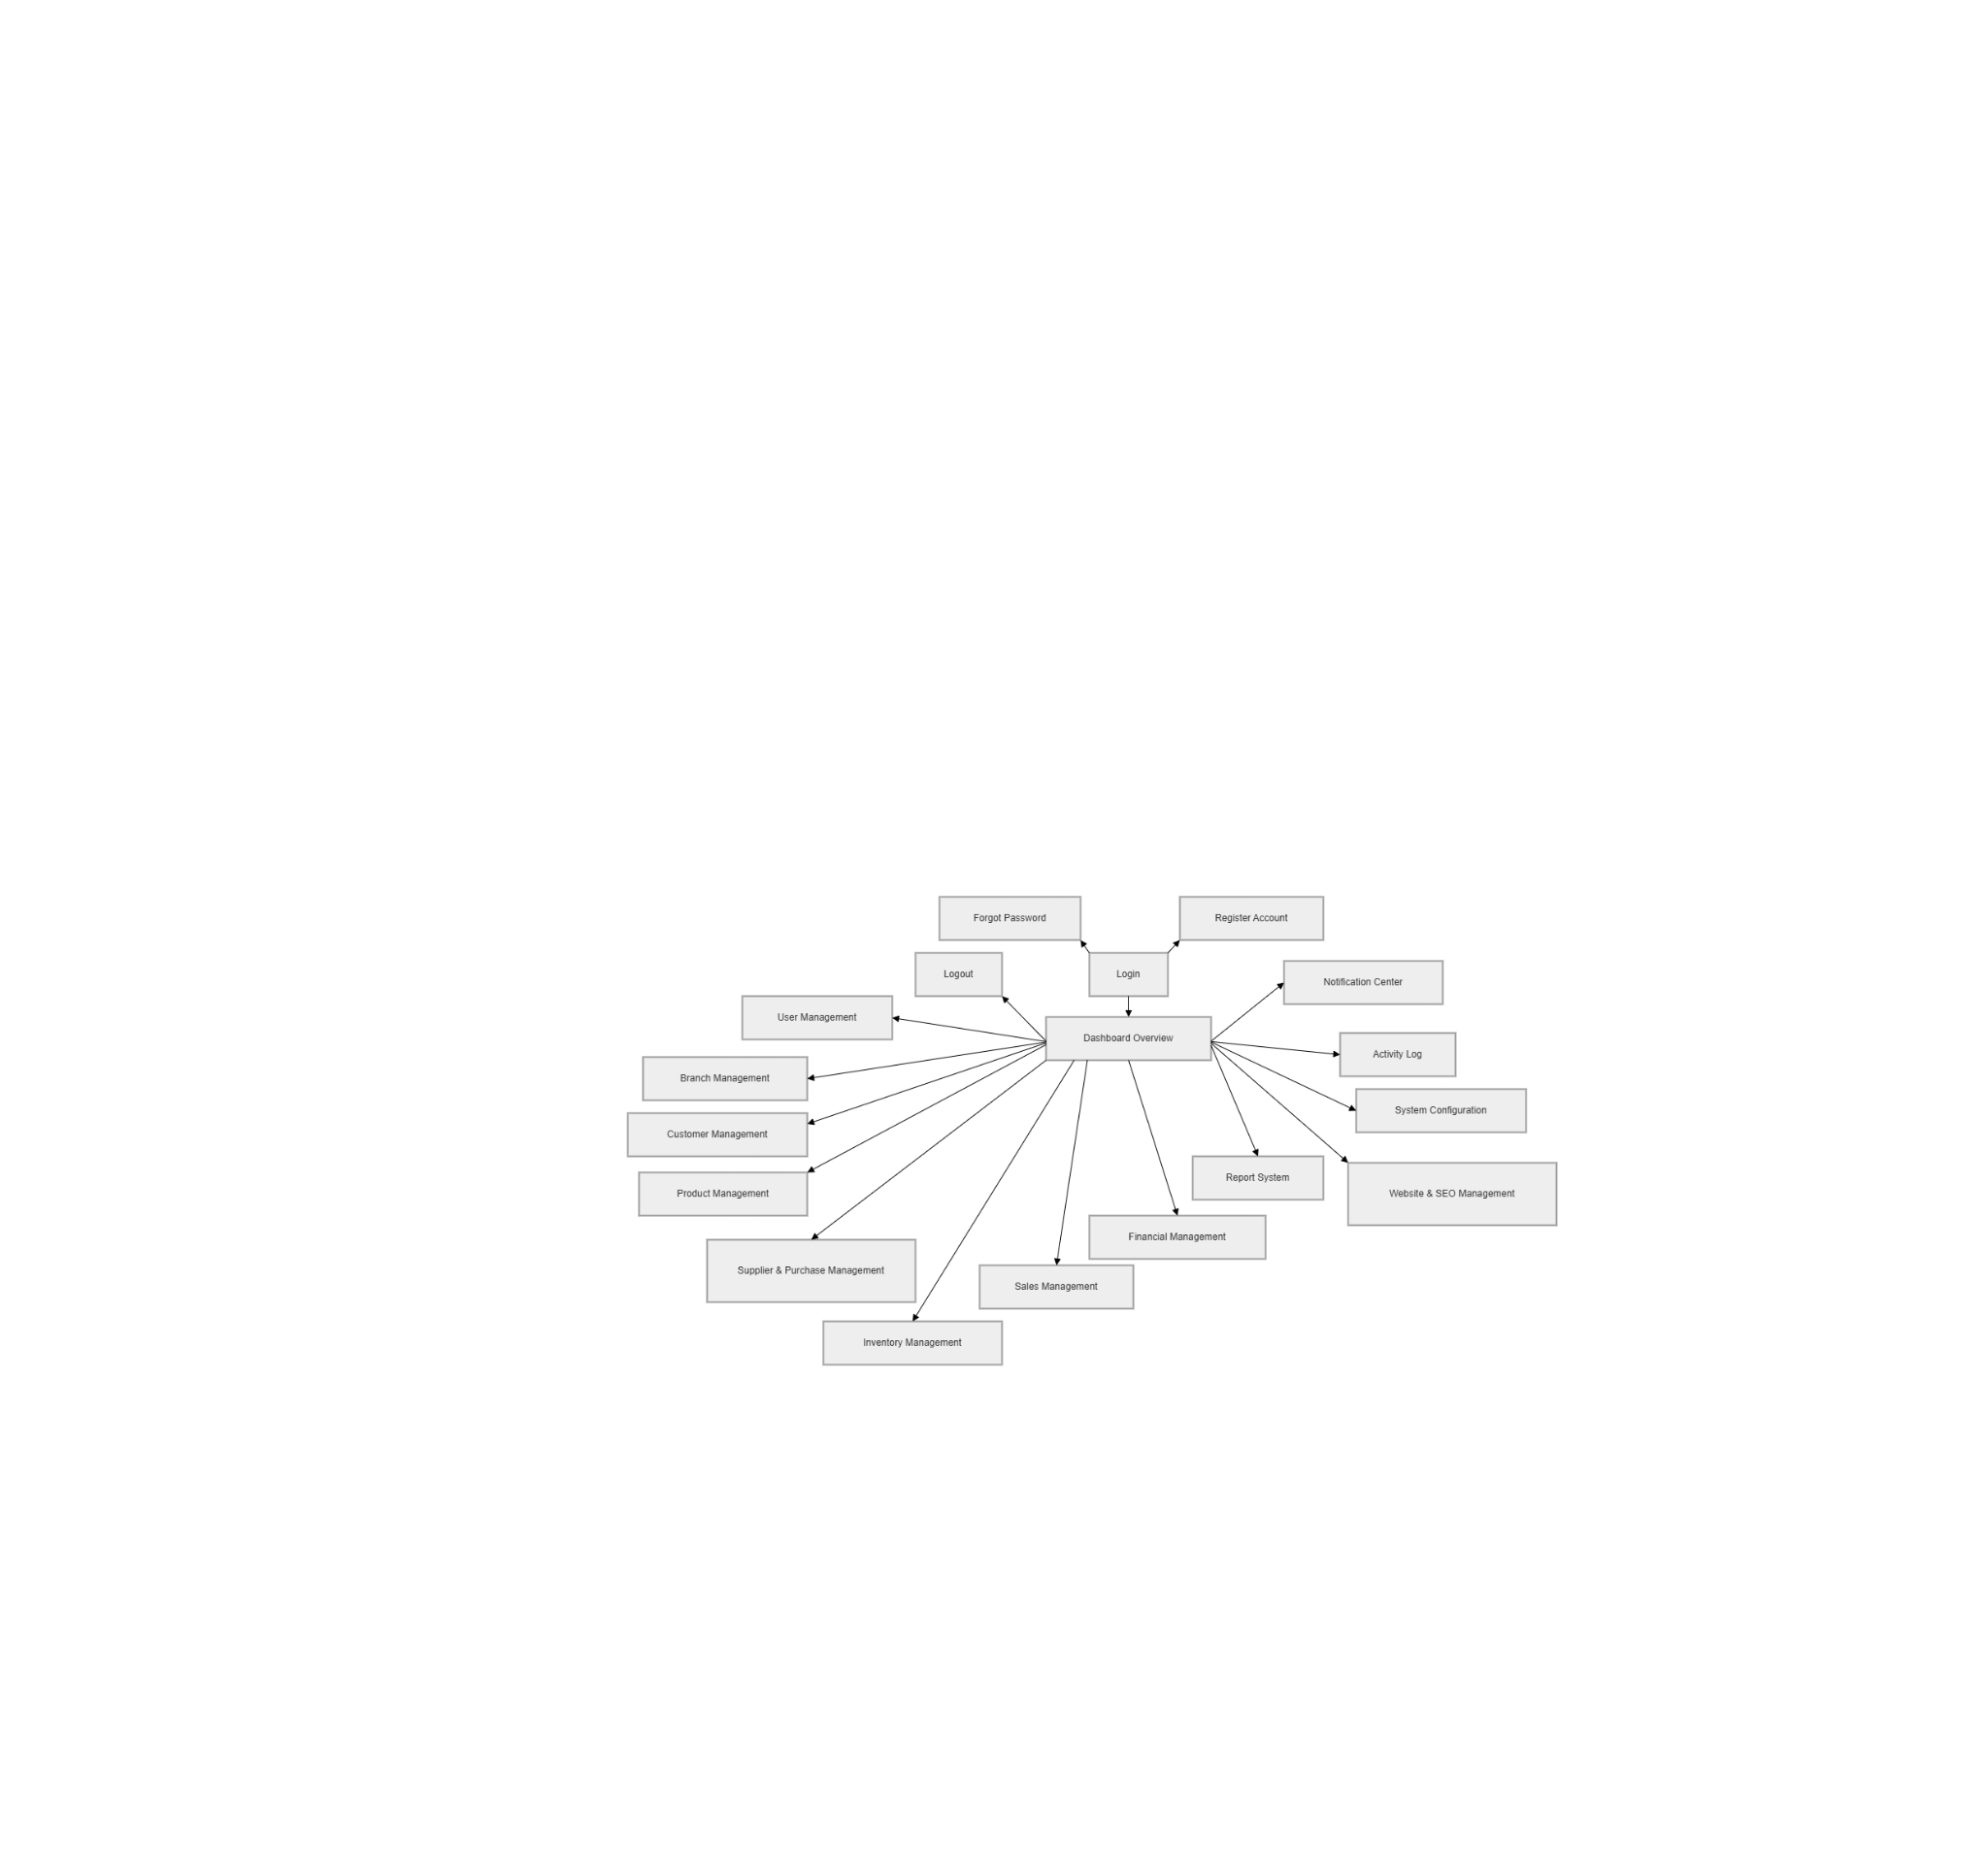

2.1.2 Authentication Flow
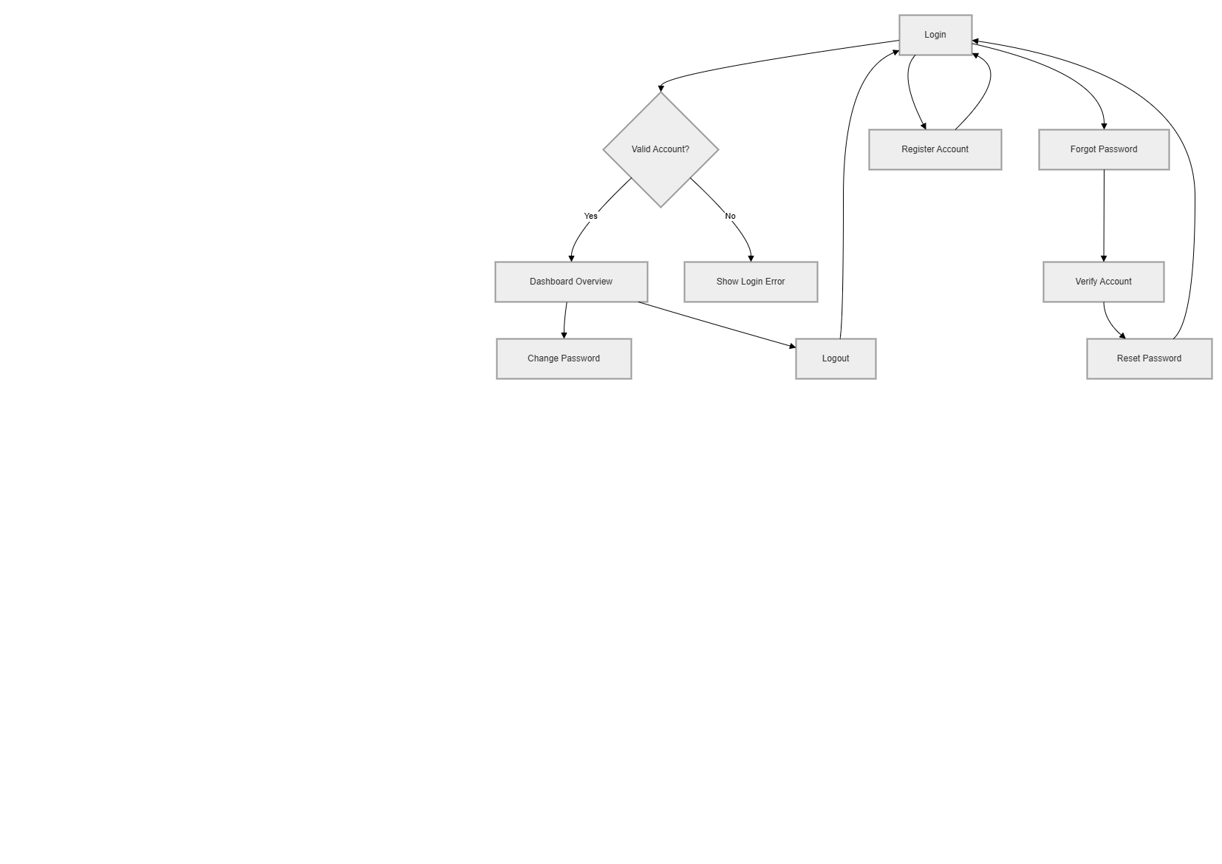

2.1.3 User and Authorization Flow

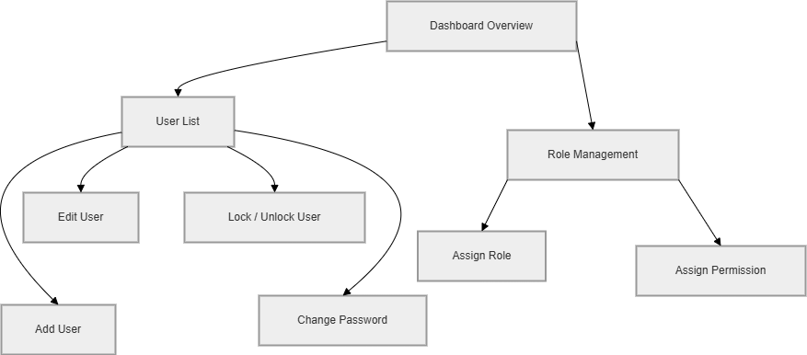

2.1.4 Branch Management Flow
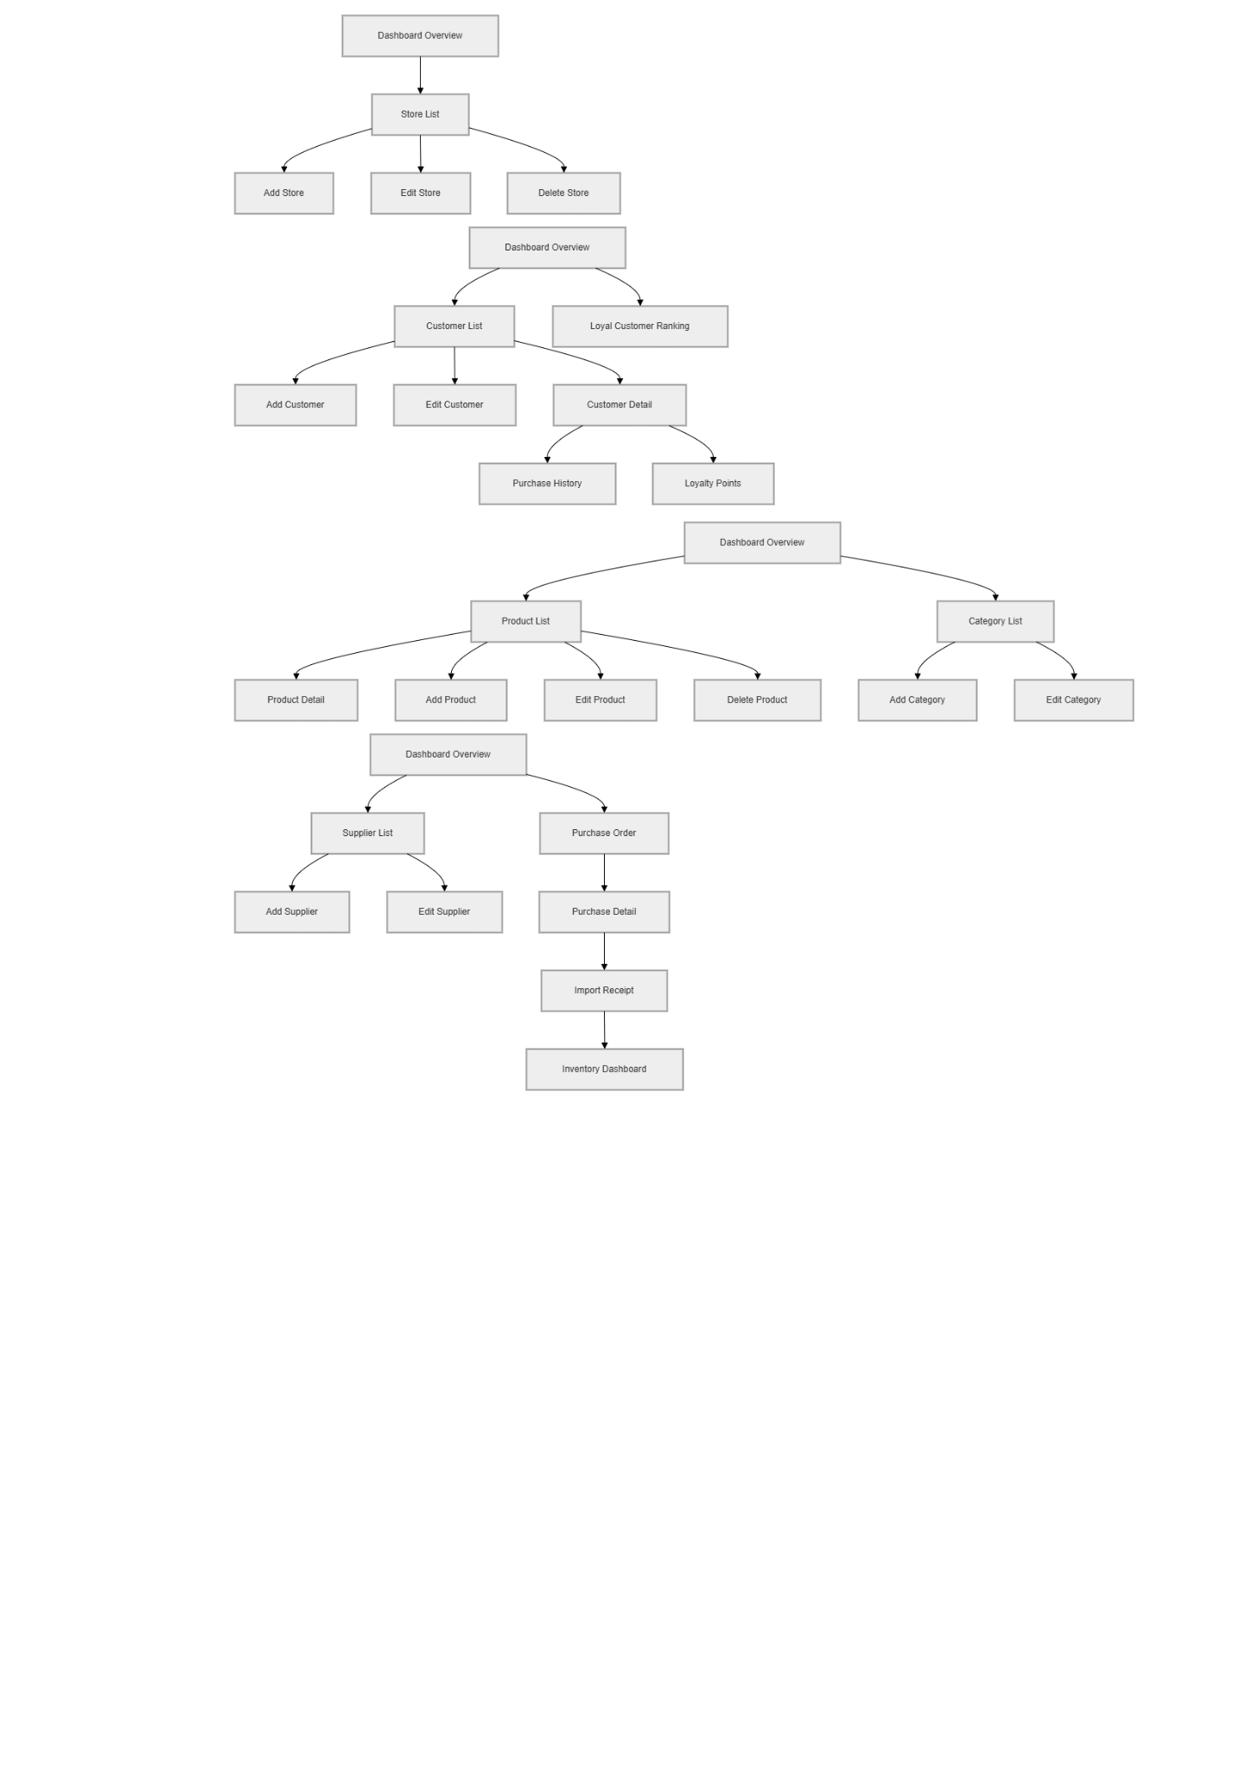

2.1.5 Customer Management Flow


2.1.6 Product and Category Management Flow


2.1.7 Supplier and Purchase Management Flow


2.1.8 Inventory Management Flow
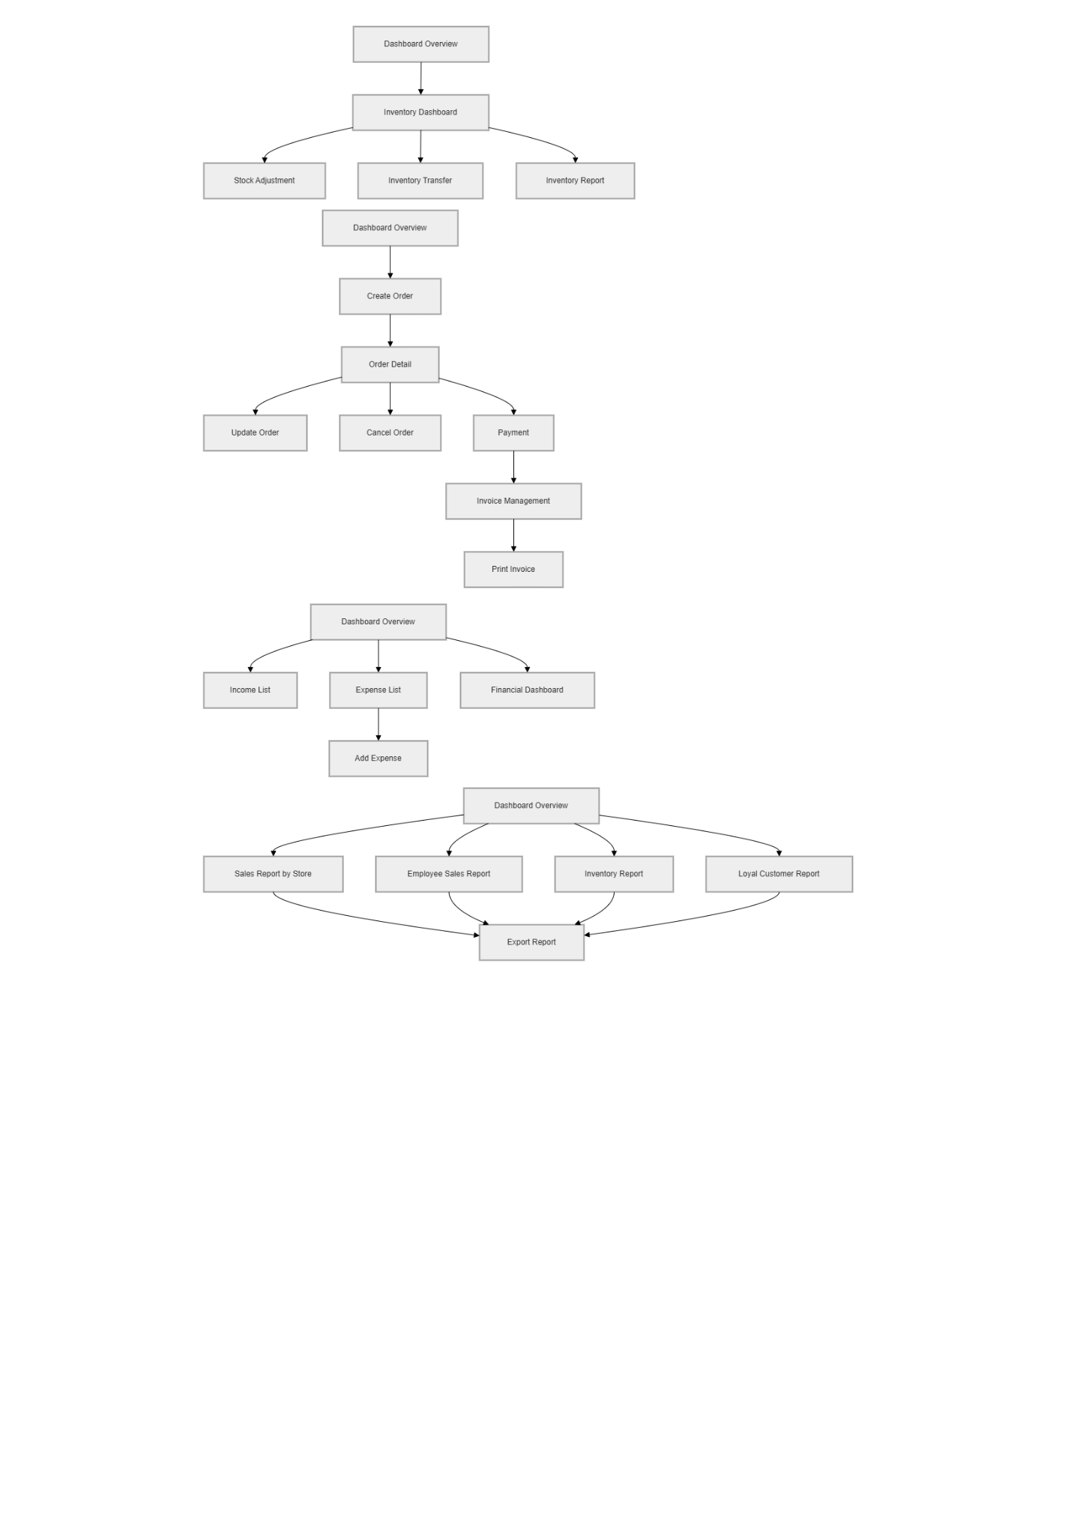

2.1.9 Sales Management Flow
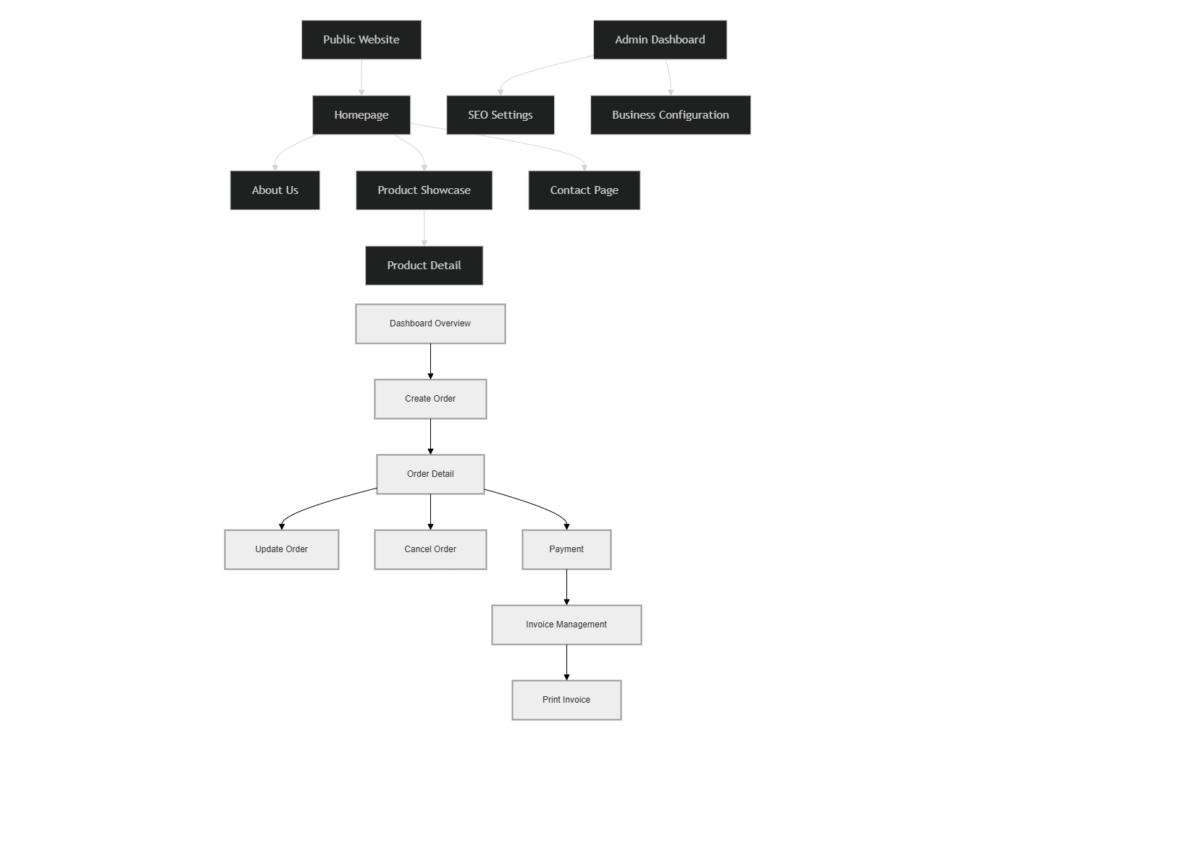

2.1.10 Financial Management Flow


2.1.11 Report System Flow


2.1.12 Website and SEO Management Flow
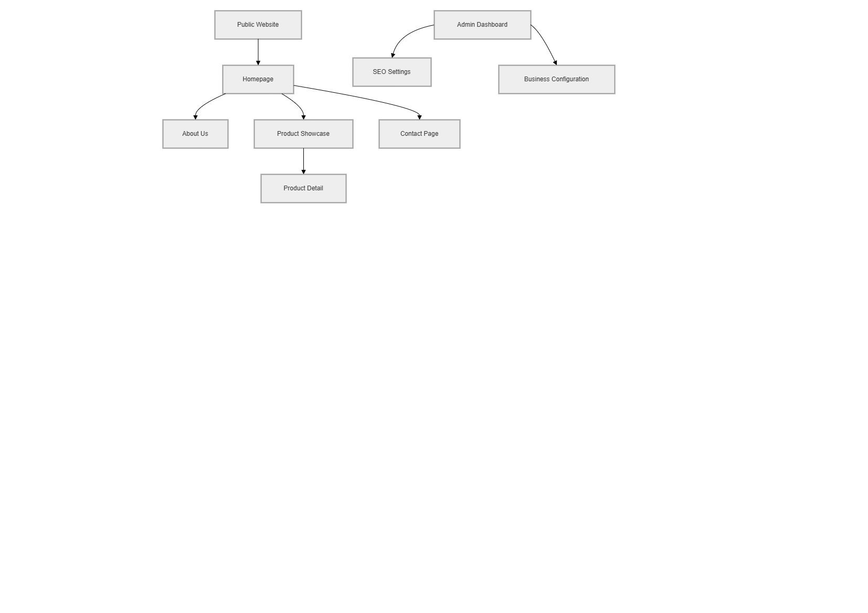

2.2 Screen Descriptions

# | Feature | Screen | Description
1 | Authentication | Login | Users enter username/email and password to access the sales management system.
2 | Authentication | Register Account | New users create an account by providing personal information and login credentials.
3 | Authentication | Forgot Password | Users recover their account password through verification and password reset process.
4 | Authentication | Logout | Users securely log out from the system after using the application.
5 | User Management | User List | Admin views and manages all user accounts in the system.
6 | User Management | Add User | Admin creates new accounts for employees and managers.
7 | User Management | Edit User | Admin updates employee account information and permissions.
8 | User Management | Lock / Unlock User | Admin locks or unlocks user accounts when necessary.
9 | User Management | Change Password | Users change their account password for security purposes.
10 | Authorization | Role Management | Admin assigns roles and permissions for different system users.
11 | Branch Management | Store List | Admin views all stores and branches in the chain system.
12 | Branch Management | Add Store | Admin adds a new branch with store information.
13 | Branch Management | Edit Store | Admin updates branch information such as address and manager.
14 | Branch Management | Delete Store | Admin removes inactive branches from the system.
15 | Customer Management | Customer List | Staff views all customer information and purchase history.
16 | Customer Management | Add Customer | Staff adds new customer information into the system.
17 | Customer Management | Edit Customer | Staff updates customer information such as phone number and address.
18 | Customer Management | Customer Detail | Staff views detailed customer profile and loyalty points.
19 | Customer Management | Loyal Customer Ranking | Admin views customer ranking based on purchase value and loyalty points.
20 | Product Management | Product List | Users view all products available for sale in the system.
21 | Product Management | Product Detail | Users view detailed product information including price and stock quantity.
22 | Product Management | Add Product | Admin or manager adds new products into the inventory system.
23 | Product Management | Edit Product | Admin or manager updates product information and pricing.
24 | Product Management | Delete Product | Admin removes products that are no longer sold.
25 | Category Management | Category List | Users view all product categories in the system.
26 | Category Management | Add Category | Admin creates new product categories.
27 | Category Management | Edit Category | Admin updates category information.
28 | Supplier Management | Supplier List | Staff views all supplier information.
29 | Supplier Management | Add Supplier | Staff adds new suppliers into the system.
30 | Supplier Management | Edit Supplier | Staff updates supplier contact information.
31 | Purchase Management | Purchase Order | Staff creates purchase orders from suppliers.
32 | Purchase Management | Purchase Detail | Staff views detailed purchase order information.
33 | Purchase Management | Import Receipt | Warehouse staff confirms imported products into warehouse inventory.
34 | Inventory Management | Inventory Dashboard | Warehouse staff monitors stock quantity and inventory status.
35 | Inventory Management | Stock Adjustment | Warehouse staff adjusts inventory quantity when discrepancies occur.
36 | Inventory Management | Inventory Transfer | Staff transfers products between branches or warehouses.
37 | Sales Management | Create Order | Sales staff creates customer sales orders for purchasing products.
38 | Sales Management | Order Detail | Staff views detailed information of customer orders.
39 | Sales Management | Update Order | Staff changes product quantity or updates order information.
40 | Sales Management | Cancel Order | Staff cancels invalid or unpaid customer orders.
41 | Sales Management | Payment | Staff processes customer payment using cash or online payment methods.
42 | Sales Management | Invoice Management | Staff generates and prints invoices after successful payment.
43 | Financial Management | Income List | Admin views all income transactions from sales activities.
44 | Financial Management | Expense List | Admin views all business expense transactions.
45 | Financial Management | Add Expense | Staff records new expense transactions into the system.
46 | Financial Management | Financial Dashboard | Admin monitors revenue, expenses, and profit statistics.
47 | Report System | Sales Report by Store | Admin views revenue reports of all branches by selected period.
48 | Report System | Employee Sales Report | Admin views sales performance reports of employees.
49 | Report System | Inventory Report | Admin and warehouse staff view inventory reports of all warehouses.
50 | Report System | Loyal Customer Report | Admin views loyal customer statistics and ranking reports.
51 | Report System | Export Report | Users export reports to Excel, PDF, or Word files.
52 | Dashboard | Dashboard Overview | Admin views overview statistics including revenue, orders, customers, and inventory.
53 | System Log | Activity Log | Admin tracks user activities such as login, update, delete, and payment actions.
54 | Notification System | Notification Center | The system displays notifications for low stock, new orders, and account activities.
55 | Website Content | Homepage | Customers view company introductions and featured products on the website.
56 | Website Content | About Us | Customers view company information, mission, and contact details.
57 | Website Content | Product Showcase | Customers browse product catalog displays on the website.
58 | Website Content | Contact Page | Customers send contact requests and feedback to the company.
59 | SEO Management | SEO Settings | Admin configures SEO metadata such as title, keywords, and descriptions for webpages.
60 | System Configuration | Business Configuration | Admin configures VAT, company information, logo, currency, and loyalty policies.

2.3 Screen Authorization

Screen | Admin | Owner | Store Manager | Sales Staff | Warehouse Staff | Guest
Login | X | X | X | X | X | X
Register Account |  |  |  |  |  | X
Forgot Password |  | X | X | X | X | X
Logout | X | X | X | X | X
User List | X | X
Add User | X | X
Edit User | X | X
Lock / Unlock User | X | X
Change Password | X | X | X | X | X
Role Management | X | X
Store List | X | X
Add Store | X | X
Edit Store | X | X
Delete Store | X | X
Customer List |  | X | X | X
Add Customer |  |  | X | X
Edit Customer |  | X | X | X
Customer Detail |  | X | X | X
Loyal Customer Ranking | X | X | X
Product List | X | X | X | X | X | X
Product Detail | X | X | X | X | X | X
Add Product | X |  | X |  | X
Edit Product |  |  | X |  | X
Delete Product |  |  | X |  | X
Category List | X | X | X | X | X | X
Add Category |  |  | X |  | X
Edit Category |  |  | X |  | X
Supplier List |  | X | X |  | X
Add Supplier |  |  | X |  | X
Edit Supplier |  |  | X |  | X
Purchase Order |  |  | X |  | X
Purchase Detail |  | X | X |  | X
Import Receipt |  |  | X |  | X
Inventory Dashboard |  | X | X |  | X
Stock Adjustment |  |  | X |  | X
Inventory Transfer |  |  | X |  | X
Create Order |  |  | X | X
Order Detail |  | X | X | X
Update Order |  |  | X | X
Cancel Order |  |  | X | X
Payment |  | X | X | X
Invoice Management |  | X | X | X
Income List | X | X
Expense List | X | X
Add Expense |  | X | X | X | X
Financial Dashboard | X | X
Sales Report by Store | X | X | X
Employee Sales Report | X | X | X
Inventory Report | X | X | X |  | X
Loyal Customer Report | X | X
Export Report | X | X | X | X | X
Dashboard Overview | X | X | X
Activity Log | X | X
Notification Center | X | X | X | X | X
Homepage | X | X | X | X |  | X
About Us | X | X | X | X |  | X
Product Showcase | X | X | X | X |  | X
Contact Page | X | X | X | X |  | X
SEO Settings | X | X | X
Business Configuration | X | X

2.4 Non-UI Functions

# | Feature | System Function | Description
1 | Point | Create Loyalty Customer | Registers a new customer into the loyalty program
2 | Point | Get All Loyalty Customer | Retrieves a list of all active and issued customer loyalty cards across the system.
3 | Point | Update Loyalty Customer | Modifies point balances, tier levels, or statuses of a specific customer loyalty card
4 | Point | Delete Loyalty Customer | Deactivates and removes a customer loyalty card from the active registry using its ID.
5 | Point | Get Loyalty CustomerSettings | Retrieves configurations for reward programs, including point conversion rules and tier benefits
6 | Point | Update Loyalty Customer Settings | Modifies loyalty program configurations, conversion rates, and expiration rules.
7 | Point | Get Customer Loyalty Card Profile | Retrieves customer information linked to a specific active loyalty card
8 | Point | Get Loyalty Cards by Filter | Filters customer loyalty accounts based on specific criteria like current tier, point range, or date issued
9 | Point | Get Customer Loyalty Histories | Retrieves transaction logs documenting points earned, spent, and adjusted for a loyalty card holder
10 | OrderReturn | Create Order Return | Creates a new return request for items purchased, adjusting stock levels and calculating potential refunds
11 | OrderReturn | Generate Order Return Code | Generates a unique reference code or transaction number for a newly initiated order return
12 | OrderReturn | Get Order Return by ID | Retrieves detailed information about an order return transaction using its ID.
13 | OrderReturn | Get Order Returns by Filter | Queries and returns lists of order returns filtered by parameters like status, customer, or date.
14 | OrderReturn | Create Refund for Return | Processes a financial refund linked to a completed order return request by ID.
15 | OrderReturn | Get Refund Details by ID | Retrieves processing logs and status for a specific refund transaction associated with an order return.
16 | Order | Post a new order | Submits and creates a new sales order with details on purchased products, customer information, applied discounts, and associated fees.
17 | Order | Approve an order | Approves and finalizes a pending order draft, moving it forward in the order fulfillment
18 | Order | Cancel an order | Cancels a placed order, releasing inventory reservations and updating the order status to cancelled accordingly
19 | Order | Finish an order | Marks an active order as fully completed after items are delivered and payments are cleared
20 | Order | Update an order | Updates details such as line items, customer notes, shipping address, or pricing terms of an existing sales order
21 | Order | Get list of orders | Retrieves a paginated list of all sales orders in the system, including their current statuses and summary information.
22 | Order | Get list of orders by ID | Retrieves the complete profile, line items, and audit trail of a specific sales order using its unique ID
23 | Order | Get list of orders by filter | Queries and returns a filtered list of sales orders based on parameters such as status, customer, date range, or order source
24 | Order | Create a payment slip | Creates a prepayment voucher for a customer who pays in advance before their order is fully processed
25 | Order | Cancel a payment slip | Cancels an existing customer prepayment voucher and corrects related billing and accounting adjustments.
26 | Order | Get order/invoice print template | Retrieves the HTML/PDF print template for an order confirmation, invoice, or packing document using the specified order IDs
27 | PriceAdjustment | get-price_adjustments | Retrieves a history list of all inventory cost/price adjustment documents made to align balance sheets and stock valuations
28 | PriceAdjustment | get-price_adjustments_id | Retrieves the full details, line items, and approval status of a specific price adjustment document by its unique ID
29 | PriceAdjustment | get-price_adjustments_codes | Generates or retrieves a unique transaction code to identify a new cost adjustment document before it is submitted.
30 | PriceAdjustment | put-price_adjustments_id | Updates details, remarks, adjusted values, or line item records in an open price adjustment document
31 | PriceAdjustment | add-price_adjustments | Creates a new price adjustment voucher to modify the recorded cost price of specific items currently held in stock.
32 | PriceAdjustment | price_adjustments_id_status | Approves, cancels, or completes a cost price adjustment voucher by updating its workflow status (e.g., draft → finalized).
33 | PriceAdjustment | import_price_adjustments_id | imports or uploads cost price adjustments in bulk through standardized file formats (e.g., Excel/CSV) to batch-update stock valuations
34 | Product | Create a new product | Adds a new product to the catalog, defining basic attributes such as title, description, category, and base price.
35 | Product | Create a product with a packsize | Creates a product along with multi-unit packaging definitions (e.g., box of 12, pack of 6, individual unit) for flexible selling
36 | Product | Get a product by ID | Retrieves complete catalog details including variants, pricing, and stock levels for a specific product by its ID.
37 | Product | Update a product | Updates general information, category tags, descriptions, images, or prices for an existing product in the catalog.
38 | Product | Delete a product | Permanently deletes a product and all of its associated variants, option lists, and pricing sheets from the system.
39 | Product | Get a product by filter | Queries products based on categories, stock availability, pricing range, active/inactive status, or tags
40 | Product | Create a new variant | Adds a specific product variant (e.g., size S/M/L, color Red/Blue) to an existing parent product.
41 | Product | Delete a variant | Removes a specific product variant from the inventory and catalog, including its pricing and stock records
42 | Product | Update a version | Modifies SKU, barcode, stock limits, weight, or pricing configurations of an existing product variant.
43 | Product | Delete multiple variants in a product | Removes multiple specified product variants under a single product simultaneously in one request.
44 | Product | Retrieve variants of a product | Retrieves a complete list of all variants (sizes, colors, configurations) associated with a specific parent product ID.
45 | Product | Filters | Filters and lists product variants system-wide based on SKU, inventory level, barcode, price range, or other criteria.
46 | StockTranfer | Create a stock transfer order | Registers a new stock relocation request to move inventory quantities between different store locations or warehouses
47 | StockTranfer | Edit a stock transfer order | Modifies transfer items, quantities, transport details, or destination warehouse on an unapproved stock relocation request.
48 | StockTranfer | Get a stock transfer order | Retrieves complete shipment listings, routing details, and current status of a stock relocation document by its ID.
49 | StockTranfer | Get the stock transfer code | Generates a unique tracking reference code for identifying and documenting a new stock relocation shipment.
50 | StockTranfer | Get a stock transfer order by filter | Retrieves a filtered list of inventory relocation requests based on origin, destination location, date, or transfer status.
51 | StockTranfer | Change the status | Updates a stock transfer document's status (e.g., draft → in-transit → completed / cancelled), adjusting stock balances accordingly
52 | StockAdjustment | Get stock adjustment orders by filter | Queries and lists stocktaking and inventory discrepancy adjustment forms based on status, date range, or warehouse.
53 | StockAdjustment | Get stock adjustment orders by filter | Retrieves detailed item audits and quantity variance records inside a specific stock adjustment/audit sheet by ID.
54 | StockAdjustment | Get stock adjustment order codes | Generates or retrieves a unique document identification code for a physical stocktaking/adjustment document.
55 | StockAdjustment | Cancel an stock adjustment order | Cancels a pending stock audit document, discarding any unapproved variance adjustments before they affect inventor y
56 | StockAdjustment | Update a stock adjustment order | Edits physical count entries and product list items inside an unsubmitted inventory adjustment form.
57 | StockAdjustment | Add a new stock adjustment order | Initiates a new physical inventory stocktaking session to reconcile actual physical stock counts with system records.
58 | StockAdjustment | Update the stock adjustment order status | Finalizes the stock reconciliation process by updating the document status, applying variance balances to active inventory counts.
59 | Voucher | Post Payment Voucher | Creates a payment (disbursement) voucher to record cash or bank transfers made to suppliers, employees, or for operational expenses.
60 | Voucher | Get Payment Voucher by ID | Retrieves financial records, payee information, and transaction details for a specific cash disbursement voucher.
61 | Voucher | Get Payment Voucher Code | Generates or retrieves a unique document identification code for a new cash disbursement voucher.
62 | Voucher | Update Payment Voucher | Updates details such as payee name, payment reason, cash account, or description on an existing payment voucher
63 | Voucher | Cancel Payment Voucher | Voids a cash disbursement voucher, reversing any debit adjustments recorded in the financial ledgers.
64 | Voucher | Get Payment Voucher by Filter | Filters and lists cash disbursement vouchers by cash account, date range, recipient group, or payment status.
65 | Voucher | Post Receipt Vouchers | Creates a receipt (collection) voucher to record incoming funds received from customers, sales, or other income sources.
66 | Voucher | Get Receipt Vouchers by ID | Retrieves detailed transaction records and payer information for a specific cash receipt voucher
67 | Voucher | Get Receipt Voucher Codes | Generates or retrieves a unique reference code for identifying a new cash receipt voucher document.
68 | Voucher | Update Receipt Vouchers | Edits descriptions, cash category classifications, payer names, or amounts on an active receipt voucher
69 | Voucher | Cancel Receipt Vouchers | Voids a cash receipt voucher, reversing credit adjustments in accounting and restoring outstanding balances.
70 | Voucher | Get Receipt Voucher Type | Retrieves a list of all classification types used to categorize and organize cash receipt vouchers in the system.
71 | Voucher | Get Receipt Voucher Type by ID | Retrieves descriptive details and configurations of a specific cash receipt voucher category/type.
72 | Voucher | Get Receipt Voucher Type Codes | Generates or retrieves a unique category reference code for classifying and identifying cash receipt voucher types.
73 | Print | Print order form | Retrieves the printable HTML/PDF template for an order confirmation form, including order details, line items, and customer information.
74 | Print | Print packing list | Retrieves the printable packing slip template for a fulfillment package, listing all items grouped per order for warehouse dispatch
75 | Print | Print goods receipt form | Retrieves the printable goods receipt note (GRN) template for recording and confirming items received from suppliers into the warehouse.
76 | Print | Print invoice | Retrieves the printable customer-facing sales invoice template, including itemized product list, tax, discounts, and total amounts.
77 | Print | Print goods receipt form | Retrieves the printable inbound goods acknowledgment form used during receiving at the warehouse, verifying quantities against purchase orders.
78 | Print | Print inspection form | Retrieves the printable stock inspection/audit form used during physical stocktaking sessions to record counted quantities per location.
79 | Print | Print receipt voucher/invoice | Retrieves the printable receipt voucher document template that serves as official proof of payment received from a customer
80 | Print | Print receipt voucher/invoice | Retrieves the printable payment voucher document template used as official record of cash or bank disbursements made to payees.
81 | PurchaseOrder | Add a new receiving order | Initiates a new purchase order draft to formally request stock replenishment from a designated supplier.
82 | PurchaseOrder | Retrieve receiving orders by filter | Lists and filters purchase/receiving orders based on parameters such as supplier, approval status, or creation date range
83 | PurchaseOrder | Retrieve a Purchase Order | Retrieves complete details, line items, costs, and audit trail of a specific purchase order using its unique ID
84 | PurchaseOrder | Generate a Purchase Order Code | Generates a unique document reference code to identify a new purchase order before it is submitted.
85 | PurchaseOrder | Cancel a Purchase Order | Cancels an active purchase order, voiding the procurement contract and releasing any pending cost allocations.
86 | PurchaseOrder | Update a Purchase Order | Edits quantities, unit prices, supplier details, or internal remarks inside a pending purchase order document
87 | PurchaseOrder | Add a New Item | Appends a new product variant line item to an existing active purchase order's item list
88 | PurchaseOrder | Add a New Purchase Invoice | Creates a supplier invoice (purchase bill) representing the cost liability associated with items received from the supplier.
89 | PurchaseOrder | Retrieve Bill Information | Retrieves financial records, tax breakdowns, and payment status of a specific supplier invoice (bill) by ID.
90 | PurchaseOrder | Update Bill Information | Edits invoice dates, line items, tax rates, or other details on an active supplier purchase bil
91 | PurchaseOrder | Retrieve Bill by Filter | Filters and lists supplier bills/invoices by payment status (unpaid, partially paid, paid), date range, or supplier
92 | PurchaseOrder | Add a New Payment Voucher for Purchase Invoices | Records a financial cash or bank transfer payment made against a supplier invoice, reducing outstanding payables.
93 | PurchaseOrder | Retrieve a Payment Voucher for Purchase Invoices | Retrieves processing status, transaction references, and amount details for a specific purchase bill payment record.
94 | PurchaseOrder | Cancel a Payment Voucher | Voids a supplier bill payment transaction, restoring the outstanding payable balance on the associated purchase invoice.
95 | PurchaseOrder | Add a New Inventory Receipt Voucher | Creates a stock procurement slip to formally record the physical quantities of goods received into the warehouse
96 | PurchaseOrder | Update an Inventory Receipt Voucher | Edits received quantity records, lot numbers, or expiry details in an open warehouse stock procurement slip
97 | PurchaseOrder | Cancel an Inventory Receipt Voucher | Voids a goods receipt document, reversing the inventory addition from warehouse logs and restoring procurement balances
98 | PurchaseOrder | Retrieve Inventory Receipt Vouchers by Filter | Retrieves warehouse receipt voucher lists filtered by date ranges, warehouse locations, or associated purchase order IDs.
99 | PurchaseOrder | Add a New Return Order | Processes a formal return of damaged or incorrect goods back to the supplier, adjusting warehouse stock levels accordingly
100 | Voucher Object | Retrieve a voucher object by ID | Retrieves detailed ledger profile, contact information, and transaction history for a specific voucher actor/recipient by its ID.
101 | Voucher Object | Retrieve the entire list of voucher objects | Retrieves a full listing of all active voucher actors in the system, including customers, suppliers, and internal staff accounts.
102 | Voucher Object | Retrieve the payment voucher group | Retrieves all classifications and groupings used for organizing and managing cash payment disbursement vouchers.
103 | Voucher Object | Retrieve the receipt voucher group | Retrieves all classifications and groupings used for organizing and managing cash receipt/collection vouchers.
104 | Branches | List Branches | Retrieves a list of business branches with optional filtering and pagination.
105 | Branches | Get Branch by ID | Retrieves details of a specific branch using its ID.
106 | Branches | Create Branch | Registers a new branch in the system.
107 | Branches | Update Branch | Modifies details of an existing branch.
108 | Branches | Delete Branch | Deletes a branch from the system
109 | Invoices | List Invoices | Retrieves a list of invoices with optional filtering and pagination.
110 | Invoices | Get Invoice by ID | Retrieves details of a specific invoice using its ID.
111 | Invoices | Create Invoice | Generates a new invoice.
112 | Invoices | Update Invoice | Modifies details of an existing invoice.
113 | Invoices | Cancel Invoice | Cancels an active invoice (updates status to Cancelled) with an optional reason.
114 | Invoices | Get Invoices by Date Range | Retrieves invoices created within a specified start and end date range.
115 | Invoices | Get Invoices by Order ID | Retrieves invoices issued from a specific order ID
116 | Invoices | Get Invoice by Code | Retrieves details of an invoice using its code
117 | Invoices | Delete Invoice | Deletes or voids an invoice with an option to void associated payments.
118 | Invoices | Get Invoices by Customer | Retrieves invoices linked to a specific customer by phone number or code.
119 | Settings | Get Settings | Retrieves the store's configurations and settings.

[Provide the descriptions for the functions which have no UI (or not screens), i.e batch/cron job, service, API, etc.]

3. System High Level Design

3.1 Database Design
[Provide the tables relationship like example below]

a. Database Schema
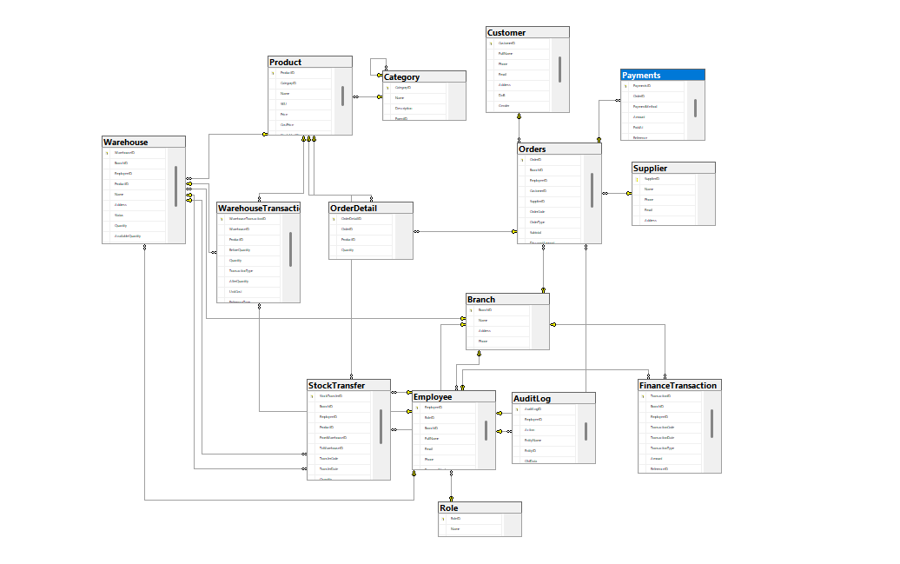

b. Table Descriptions
No | Table | Description
01 | Role | Stores all system roles (e.g. manager, cashier, warehouse staff) that can be assigned to employees.  Primary keys: roleID  +
02 | Branch | Stores branch information of the business system. Each branch can manage employees, warehouses, orders, and financial transactions. Primary keys: BranchID
03 | Employee | Stores employee information working at a specific branch. Each employee is assigned a role and can create orders, warehouse transactions, stock transfers, and finance records.  Primary keys: EmployeeID  Foreign keys: roleID → Role, BranchID → Branch
04 | AuditLog | Records all important actions performed by employees in the system, including modified entity information and old/new data snapshots for auditing purposes.  Primary keys: AuditLogID  Foreign keys: EmployeeID → Employee
05 | Category | Stores product categories with hierarchical parent–child relationships using self-reference.  Primary keys: CategoryID  Foreign keys: parent_id → Category
06 | Product | Stores product information including SKU, selling price, cost price, stock alert threshold, and category classification.  Primary keys: ProductID  Foreign keys: CategoryID → Category
07 | Customer | Stores customer information including contact details, membership tier, and accumulated loyalty points.  Primary keys: CustomerID
08 | Provider | Stores supplier/provider information used for purchasing goods into the system.  Primary keys: ProviderID
09 | Warehouse | Stores warehouse information belonging to a branch. Warehouses are used to manage product stock quantities.  Primary keys: WarehouseID  Foreign keys:  BranchID → Branch,  EmployeeID → Employee,  ProductID → Product.
10 | WarehouseTransaction | Records all warehouse stock movements including imports, exports, stock adjustments, and transfers. Tracks stock quantity before and after each transaction.  Primary keys: WarehouseTransactionID  Foreign keys: WarehouseID → Warehouse, ProductID → Product
11 | StockTransfer | Stores stock transfer operations between warehouses, including source warehouse, destination warehouse, responsible employee, and transferred product quantity.  Primary keys: StockTransferID  Foreign keys:  BranchID → Branch,  EmployeeID → Employee,  ProductID → Product,  FromWarehouseID → Warehouse,  ToWarehouseID → Warehouse.
12 | Order | Stores sales and purchase order information created at a branch. Orders may be linked to customers or providers depending on order type. Primary keys: OrderID  Foreign keys:  BranchID → Branch,  EmployeeID → Employee,  CustomerID → Customer,  ProviderID → Provider.
13 | OrderDetail | Stores detailed line items of products within an order, including quantity, unit price, and subtotal for each product.  Primary keys: OrderDetailID  Foreign keys: OrderID → Order, ProductID → Product
14 | Payments | Stores payment records associated with orders, supporting multiple payment methods and payment statuses.  Primary keys: PaymentsID  Foreign keys: OrderID → Order
15 | FinanceTransaction | Records all financial income and expense transactions generated by branches, including references to related business operations.  Primary keys: TransactionID  Foreign keys: BranchID → Branch, EmployeeID → Employee

3.2 Code Packages
Package descriptions
No | Package | Description
01 | authentication | Handles user authentication and session management for employees. Supports login, logout, JWT access token generation, refresh token handling, and password recovery/reset features.
02 | authorization | Manages role-based access control (RBAC). Defines permissions for each system role such as admin, manager, cashier, and warehouse staff.
03 | branch_management | Manages branch information including branch creation, updates, address management, phone number, and branch operating status.
04 | employee_management | Manages employee accounts within branches, including role assignment, profile management, account status, password handling, and employee information updates.
05 | audit_log | Records all important actions performed by employees in the system including create, update, delete, and status change operations. Stores old and new data snapshots for traceability.
06 | category_management | Manages product categories and category hierarchy using parent–child relationships. Supports category creation, updates, and status management.
07 | product_management | Manages product information including SKU, product name, selling price, cost price, stock alert quantity, status, and category assignment.
08 | provider_management | Manages provider/supplier information including contact details, address, email, phone number, and provider status.
09 | warehouse_management | Manages warehouse information associated with branches including warehouse creation, address management, responsible employee assignment, and warehouse status.
10 | warehouse_transaction | Handles warehouse stock movement operations including stock import, export, adjustment, and inventory updates. Tracks before quantity and after quantity for each transaction.
11 | stock_transfer | Manages stock transfer operations between warehouses. Handles transfer requests, transfer status, source warehouse, destination warehouse, transferred products, and quantity tracking.
12 | customer_management | Manages customer information including personal details, membership tier, loyalty points, and customer contact information.
13 | order_management | Manages order processing for both sales and purchase operations. Handles order creation, order status, subtotal/discount calculations, and customer/provider association.
14 | order_detail_management | Manages product line items inside orders including product quantity, unit price, and subtotal calculations for each order item.
15 | payment_management | Processes payments related to orders. Supports multiple payment methods such as cash, bank transfer, card, and e-wallet. Tracks payment status and payment references.
16 | financial_transaction | Records all branch financial transactions including income, expenses, operational costs, and other financial activities linked to employees and business operations.

II. Requirement Specifications

1. <<Feature Name>>

1.1 <<UseCaseCode_UC Name>>

a. Functionalities
Provide the functional description for the use cases using the template/guides below
Functional Description Template
UC ID and Name:
Created By: |  | Date Created:
Primary Actor: |  | Secondary Actors:
Trigger:
Description:
Preconditions:
Postconditions:
Normal Flow:
Alternative Flows:
Exceptions:
Priority: | High (Medium, Low), Must Have (Should Have, Could Have),..
Frequency of Use:
Business Rules:
Other Information:
Assumptions:

Functional Description Contents
Use Case ID and Name
Give each use case a unique integer sequence number identifier. State a concise name for the use case that indicates the value the use case would provide to some user. Begin with an action verb, followed by an object.
Author and Date Created
Enter the name of the person who initially wrote this use case and the date it was written.
Primary and Secondary Actors
An actor is a person or other entity external to the software system being specified who interacts with the system and performs use cases to accomplish tasks. Different actors often correspond to different user classes, or roles, identified from the customer community that will use the product. Name the primary actor that will be initiating this use case and any other secondary actors who will participate in completing execution of the use case.
Trigger
Identify the business event, system event, or user action that initiates the use case. This trigger alerts the system that it should begin testing the preconditions for the use case so it can judge whether to proceed with execution.
Description
Provide a brief description of the reason for and outcome of this use case, or a high-level description of the sequence of actions and the outcome of executing the use case.
Preconditions
List any activities that must take place, or any conditions that must be true, before the use case can be started. The system must be able to test each precondition. Number each precondition. Example: PRE-1: User’s identity has been authenticated.
Postconditions
Describe the state of the system at the successful conclusion of the use case execution. Label each postcondition in the form POST-X, where X is a sequence number. Example: POST-1: Price of item in the database has been updated with the new value.
Normal Flow
Provide a description of the user actions and corresponding system responses that will take place during execution of the use case under normal, expected conditions. This dialog sequence will ultimately lead to accomplishing the goal stated in the use case name and description. Show a numbered list of actions performed by the actor, alternating with responses provided by the system. The normal flow is numbered “X.0”, where “X” is the Use Case ID.
Alternative Flows
Document other successful usage scenarios that can take place within this use case. State the alternative flow, and describe any differences in the sequence of steps that take place. Number each alternative flow in the form “X.Y”, where “X” is the Use Case ID and Y is a sequence number for the alternative flow. For example, “5.3” would indicate the third alternative flow for use case number 5. Indicate where each alternative flow would branch off from the normal flow, and if pertinent, where it would rejoin the normal flow.
Exceptions
Describe any anticipated error conditions that could occur during execution of the use case and how the system is to respond to those conditions. Number each alternative flow in the form “X.Y.EZ”, where “X” is the Use Case ID, Y indicates the normal (0) or alternative (>0) flow during which this exception could take place, “E” indicates an exception, and “Z” is a sequence number for the exceptions. For example “5.0.E2” would indicate the second exception for the normal flow for use case number 5. Indicate where in the normal (or an alternative) flow each exception could occur.
Priority
Indicate the relative priority of implementing the functionality required to allow this use case to be executed. Use the same priority scheme as that used for the functional requirements.
Frequency of Use
Estimate the number of times this use case will be performed per some appropriate unit of time. This gives an early indicator of throughput, concurrent usage loads, and transaction capacity.
Business Rules
List any business rules that influence this use case. Don’t include the business rule text here, just its identifier so the reader can find it in another repository when needed.
Other Information
Identify any additional requirements, such as quality attributes, for the use case that may need to be addressed during design or implementation. Also list any associated functional requirements that aren’t a direct part of the use case flows but which a developer needs to know about. Describe what should happen if the use case execution fails for some unanticipated or systemic reason (e.g., loss of network connectivity, timeout). If the use case results in a durable state change in a database or the outside world, state whether the change is rolled back, completed correctly, partially completed with a known state, or left in an undetermined state as a result of the exception.
Assumptions
List any assumptions that were made regarding this use case or how it might execute.

b. Business Rules
Provide the business rules those are applied only to the use case
ID | Business Rule | Business Rule Description
FR1 | Password Encoding | User’s password must be encoded with MD5 hashing

2. Common Functions

2.1 UC-2_Login System

a. Functional Description
UC ID and Name: | UC-2_Login System
Created By: | MinhNNT | Date Created: | 16/Jun/2023
Primary Actor: | Customer | Secondary Actors: | None
Trigger: | User clicks Login button from the page header, or  User accesses an authenticated feature (from a link or type the page URL directly into the address bar)
Description: | As a user, I want to be able to log into the system so that I can use the system’s authenticated features and access my personalized account.
Preconditions: | User account has been created & authorized
Postconditions: | · User logs in the system successfully  · The system tracked successful login into the Activity Log
Normal Flow | 2.0 Login System  1. User accesses the User Login screen  2. User types in the login details or choo other login options (see 2.1 and 2.2)  3. User clicks the Login button  4. System validates the login details (see 2.0.E1)  5. System allows user to access  6. System tracks user’s success login to the Activity Log  7. System accesses the Home Page (or the previous calling page if any)
Alternative Flows: | 2.1 Google Login  1. User chooses to login system using Google account  2. System redirects the user to the Google’s Login screen  3. User types in the Google account details and chooses to login  4. Google validates user’s login information successfully and redirect him/her back to the system  5. Return to step 5 of normal flow.  2.2 Facebook Login  1. User chooses to login system using Facebook account  2. System redirects the user to the Facebook’s Login screen  3. User types in the Facebook account details and chooses to login  4. Facebook validates user’s login information successfully and redirect him/her back to the system  5. Return to step 5 of normal flow.
Exceptions: | 2.0.E1 System can’t authenticate the user  1. The Error Message screen is shown to the user  2. User cancels the logging in => UC stops, change to UC-1_View Home Page  3. User clicks “Forgot Password?” link => change to UC-3_Reset Password  4. User clicks “Register” link => change to UC-4_Register User Account
Priority: | Must Have
Frequency of Use:
Business Rules: | FR1, FR2, FR3
Other Information:
Assumptions:

b. Business Rules
ID | Business Rule | Business Rule Description
FR1 | Password Encoding | User’s password must be encoded with MD5 hashing
FR2 | Invalid Logging In | User can’t be authenticated to login the system if below cases  · His/her logging-in details are incorrect  · His/her account has not been verified  · His/her account has been locked or blocked
FR3 | Account Locking | If user inputs wrong logging-in details 6 times continuously, his/her account would be locked in 30 minutes

3. Patron Feature

3.1 UC-5_Order a Meal

a. Functional Description
ID and Name: | UC-5 Order a Meal
Created By: | Prithvi Raj | Date Created: | 10/4/13
Primary Actor: | Patron | Secondary Actors: | Cafeteria Inventory System
Description: | A Patron accesses the Cafeteria Ordering System from the corporate intranet or from home, views the menu for a specific date if desired, selects food items, and places an order for a meal to be delivered to a specified location within a specified 15-minute time window.
Trigger: | A Patron indicates that he wants to order a meal
Preconditions: | PRE-1. Patron is logged into COS.  PRE-2. Patron is registered for meal payments by payroll deduction.
Postconditions: | POST-1. Meal order is stored in COS with a status of “Accepted”.  POST-2. Inventory of available food items is updated to reflect items in this order.  POST-3. Remaining delivery capacity for the requested time window is updated.
Normal Flow: | 5.0 Order a Single Meal  1. Patron asks to view menu for a specific date. (see 5.0.E1, 5.0.E2)  2. COS displays menu of available food items and the daily special.  3. Patron selects one or more food items from menu. (see 5.1)  4. Patron indicates that meal order is complete. (see 5.2)  5. COS displays ordered menu items, individual prices, and total price, including taxes and delivery charge.  6. Patron either confirms meal order (continue normal flow) or requests to modify meal order (return to step 2).  7. COS displays available delivery times for the delivery date.  8. Patron selects a delivery time and specifies the delivery location.  9. Patron specifies payment method.  10. COS confirms acceptance of the order.  11. COS sends Patron an email message confirming order details, price, and delivery instructions.  12. COS stores order, sends food item information to Cafeteria Inventory System, and updates available delivery times.
Alternative Flows: | 5.1 Order multiple identical meals  1. Patron requests a specified number of identical meals. (see 5.1.E1)  2. Return to step 4 of normal flow.  5.2 Order multiple meals  1. Patron asks to order another meal.  2. Return to step 1 of normal flow.
Exceptions: | 5.0.E1 Requested date is today and current time is after today’s order cutoff time  1. COS informs Patron that it’s too late to place an order for today.  2a. If Patron cancels the meal ordering process, then COS terminates use case.  2b. Else if Patron requests another date, then COS restarts use case.  5.0.E2 No delivery times left  1. COS informs Patron that no delivery times are available for the meal date.  2a. If Patron cancels the meal ordering process, then COS terminates use case.  2b. Else if Patron requests to pick the order up at the cafeteria, then continue with normal flow, but skip steps 7 and 8.  5.1.E1 Insufficient inventory to fulfill multiple meal order  1. COS informs Patron of the maximum number of identical meals he can order, based on current available inventory.  2a. If Patron modifies number of meals ordered, then Return to step 4 of normal flow.  2b. Else if Patron cancels the meal ordering process, then COS terminates use case.
Priority: | High
Frequency of Use: | Approximately 300 users, average of one usage per day. Peak usage load for this use case is between 9:00 A.M. and 10:00 A.M. local time.
Business Rules: | BR-1, BR-2, BR-3, BR-4, BR-11, BR-12, BR-33
Other Information: | 1. Patron shall be able to cancel the meal ordering process at any time prior to confirming it.  2. Patron shall be able to view all meals he ordered within the previous six months and repeat one of those meals as the new order, provided that all food items are available on the menu for the requested delivery date. (Priority = M)  3. The default date is the current date if the Patron is using the system before today’s order cutoff time. Otherwise, the default date is the next day that the cafeteria is open.
Assumptions: | Assume that 15 percent of Patrons will order the daily special (source: previous 6 months of cafeteria data).

b. Business Rules
None

3.2 UC-6_Register for Payroll Deduction

a. Functional Description
ID and Name: | UC-6 Register for Payroll Deduction
Created By: | Nancy Anderson | Date Created: | 9/15/13
Primary Actor: | Patron | Secondary Actors: | Payroll System
Description: | Cafeteria patrons who use the COS and have meals delivered must be registered for payroll deduction. For noncash purchases made through the COS, the cafeteria will issue a payment request to the Payroll System, which will deduct the meal costs from the next scheduled employee payday direct deposit.
Trigger: | Patron requests to register for payroll deduction, or Patron says yes when COS asks if he wants to register
Preconditions: | PRE-1. Patron is logged into COS.
Postconditions: | POST-2. Patron is registered for payroll deduction.
Normal Flow: | 6.0 Register for Payroll Deduction  1. COS asks Payroll System if Patron is eligible to register for payroll deduction.  2. Payroll System confirms that Patron is eligible to register for payroll deduction.  3. COS asks Patron to confirm his desire to register for payroll deduction.  4. If so, COS asks Payroll System to establish payroll deduction for Patron.  5. Payroll System confirms that payroll deduction is established.  6. COS informs Patron that payroll deduction is established.
Alternative Flows: | None
Exceptions: | 6.0.E1 Patron is not eligible for payroll deduction  6.0.E2 Patron is already enrolled for payroll deduction
Priority: | High
Business Rules: | BR-86 and BR-88 govern an employee’s eligibility to enroll for payroll deduction.
Other Information: | Expect high frequency of executing this use case within first 2 weeks after system is released.

b. Business Rules
None

III. Design Specifications

1. <<Feature Name>>

1.1 <<SubFeature Name>>

a. <<Screen/Function Name>>
[Provide brief description of the screen/function + related UC here and other details as in the sub-sections]

UI Design
[This is to describe the UI layout (Mockup prototype) & descriptions for screen fields/components]
<<Mockup prototype>>
Field Name | Field Type | Description
Field Group Name
<<Field-Name>> | <<Field type>> | <<Field description & data initializing design>>

Database Access
[Provide the design description for the screen/function to access the database here: what table the screen/function would access, which transactions does it make (C-Create, R-Read, U-Update, or D-Delete), and how/purpose of the access (by providing Description and SQL commands)]
Table | CRUD | Description
<<Table Name>> | <<transaction(s)>> | <<Table access description: purpose, how,…>>
..

SQL Commands
[Provide the detailed SQL (select, insert, update...) which are used in implementing the screen/function]

1.2 System Access

a. User Login
This screen allows user to be authenticated to the system screens/functionalities.
Related use cases:
· UC02_Login System

UI Design

Field Name | Field Type | Description
Email* | Text Box | This is for user to input valid email address for logging in
Password* | Password Box | This is for user to input password for logging in
Login | Button | User clicks to authenticate him/herself into the system with provided email & password
Register | Button | User clicks to redirect to the User Register page for registering new user account to access the system
Forgot Password? | Hyperlink | User clicks to redirect to the Password Reset page for resetting his/her forgot password
Login with Google | Hyperlink | Allow user to login with his/her Google account
Login with Facebook | Hyperlink | Allow user to login with his/her Facebook account

Database Access
Table | CRUD | Description
User | R | Verify UserName & Password information
Setting, User | R | Specify the authorizations of the logged-in user

SQL Commands:
1/ Verify UserName & Password information
SELECT user_id, full_name, email, image_url, status
FROM user WHERE user_name = ? AND password = ?

2/ Specify the authorizations of the logged-in user
SELECT mapped_values FROM setting WHERE setting_id = ?
SELECT setting_name, mapped_values FROM setting WHERE setting_id IN (?)

b. Setting List

UI Design

Field Name | Field Type | Description
Search Fields
Setting Type | Combo Box  Single-Choice | Filled with the list of current active setting types  Allow to filter the list by setting type;  Default value is “All Types”
Setting Status | Combo Box  Single-Choice | Values: All Statuses (default), Active, and Inactive  Allow to filter the list by status  Default value: “All Statuses”
Search Phase | Text Box  String (30) | Allow to search using the name or map values  Default value: blank
Search | Button | Click to refresh the list with the defined filter(s) and search phrase.
Add New | Hyperlink | Click to open the Setting Details page for adding new setting (master data)
Data Table
ID | Integer | Auto-increased identifier of the setting
Name | Text | Name of the setting
Mapped Values | Text | Supplementary information for the setting
Type | Text | Type of the setting
Order | Integer | Display order of the setting: the order of the setting type, displayed among the list of settings with the same type
Data Actions
Edit | icon | Click to open the Setting Details page for updating the relevant setting (master data)
Activate | icon | Shown when the data status is inactive. This is to activate the relevant setting (master data)
Deactivate | Ion | Shown when the data status is active. This is to deactivate the relevant setting (master data)

Database Access
Table | CRUD | Description
Setting | RU | Query the list of current settings from the database  Update status of a specific setting

SQL Commands:
1/ Query the list of current settings from the database
SELECT setting_id, setting_name, mapped_values, type_id, display_order, status
FROM setting WHERE (setting_type = ?) AND (status = ?) AND (setting_name LIKE ?)

2/ Update status of a specific setting
UPDATE setting SET status = ? WHERE setting_id = ?

c. Setting Details

UI Design

Field Name | Field Type | Description
Name* | Text Box  String (20) | Name of the setting
Type* | Combo Box  (Single Choice) | Type of the setting, filled with the list of setting types  Default value: the first type in the list
Mapped Values | Text Box  String (50) | Supplementary information for the setting (if any)
Order | Text Box  Integer (>=0) | Display order of the setting: the order of the setting type, displayed among the list of settings with the same type
Status | On/Off button | Status of the setting: Active or Inactive  Default value: Active
Description | Text Area  String (200) | Description of the setting
Submit | Button | Click to store new or updated setting details
Reset | Button | Click to reset the changes use has made on the screen fields back to the initial values when the screen is loaded

Database Access
…

IV. Appendix
1.
2.
3.

1. Assumptions & Dependencies
[Record any assumptions that were made when conceiving the project and writing this vision and scope document. Note any major dependencies the project must rely upon for success, such as specific technologies, third-party vendors, development partners, or other business relationships.]
<<Sample:
AS-1: Systems with appropriate user interfaces will be available for cafeteria employees to process the expected volume of meals ordered.
AS-2: Cafeteria staff and vehicles will be available to deliver all meals for specified delivery time slots within 15 minutes of the requested delivery time.
DE-1: If a restaurant has its own on-line ordering system, the Cafeteria Ordering System must be able to communicate with it bi-directionally.
>>

2. Limitations & Exclusions
[Identify any product features or characteristics that a stakeholder might anticipate, but which are not planned to be included in the new product]

3. Business Rules
[Provide common business rules that you must follow. The information can be provided in the table format as the sample below]
<<Sample
ID | Category | Rule Definition
BR-01 | Constraints | Delivery time windows are 15 minutes, beginning on each quarter hour.
BR-02 | Constraints | Deliveries must be completed between 10:00 A.M. and 2:00 P.M. local time, inclusive.
BR-03 | Facts | All meals in a single order must be delivered to the same location.
BR-04 | Facts | All meals in a single order must be paid for by using the same payment method.
BR-11 | Constraints | If an order is to be delivered, the patron must pay by payroll deduction.
BR-12 | Computations | Order price is calculated as the sum of each food item price times the quantity of that food item ordered, plus applicable sales tax, plus a delivery charge if a meal is delivered outside the free delivery zone.
>>

4. ..

